**User Story Name: Facebook Login for Website**

* Description: **As a** User **I would like** to be able to login to my SkillCourt account through Facebook **so that** I can have access to my user stats and previous games

Acceptance Criteria

* Facebook ‘Login’ button appears on ‘Login’ screen and is pressable
* Once clicked, the user is passed to a Facebook login popup which directs the user through the Facebook login process and is then redirected to the logged in screen.

**Use Case**

* Name: Facebook Login
* Actor: User
* Preconditions: User is currently on the ‘Login’ page
* Description <Flow of events>:

|  |  |
| --- | --- |
| Actor Steps | System Steps |
| 1. Actor clicks on ‘Log in with Facebook’ button |  |
|  | 2. Popup window appears requesting Facebook credentials |
| 3. User enters Facebook credentials (Username and Password) |  |
| 4. User clicks ‘Login’ button in popup window |  |
|  | 5. User is logged into system |
|  | 6. User is redirected to ‘My Account’ Page |

**Use Case Diagram**

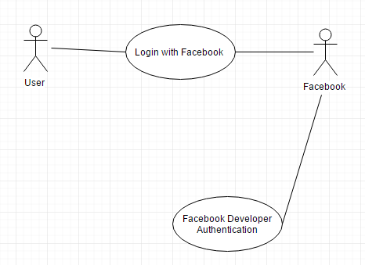

**Sequence Diagram**

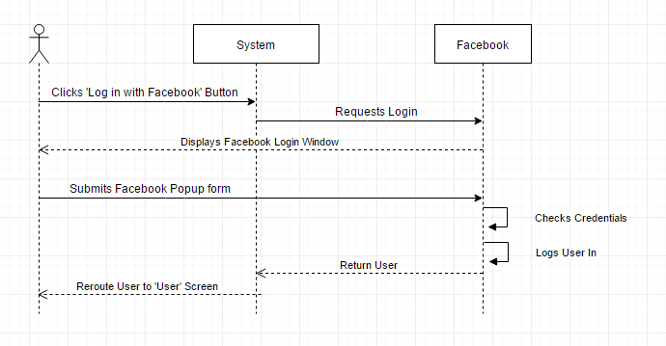

**Class Diagram**

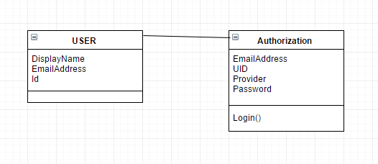

**Unit Test**

* Test case ID: Facebook Login
* Description/Summary of Test: Test that a user can be logged into SkillCourt with their Facebook credentials
* Pre-condition: The user has an account with Facebook
* Expected Results: successfully logs into the system with correct username/password
* Actual Result: login was successful
* Status (Fail/Pass): Pass

**Integration Test**

**Visual User Guide:**

